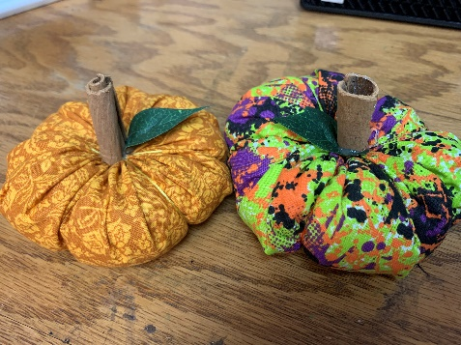
Stuffed Pumpkins

To make this you’ll need:
- long needle (mine was over 2” long - even a little longer would be better)
- Any color thread
- Glue Gun
The following items are provided:
- Halloween fabric circles
- Embroidery Thread
- Filler
- Cinnamon Sticks
- Leaf

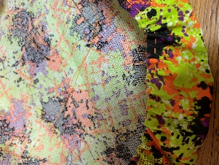
  - With any color thread, stitch a long basting stitch 1/4” from the edge on both long sides of the fabric. Start and stop your stitching a hair over 1/4” from each end. Leave the thread tails long.

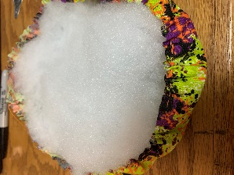
  - Fill the fabric with filler.

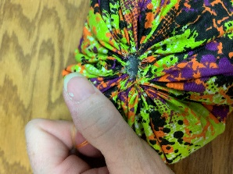
  - Pull the basting tails to gather the bottom. Pull as tight as possible without breaking the thread. Tie off.
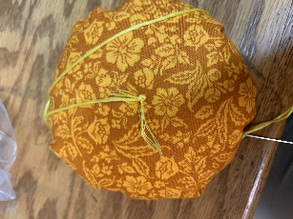
  - With the embroidery thread, stitch up through the center using the long needle and embroidery thread. Be sure to stitch through the fabric on both ends. Make 5 – 6 loops on outside of the pumpkin always returning to the center. Stitch up from the bottom to the top and tie off.

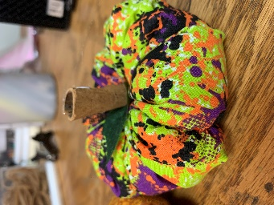
  - Trim your cinnamon sticks to make a stem. With the hot glue gun attach the leaf and stem in the center of the pumpkin.

  - Display for your holiday festivities.

There are enough supplies in each bag to make 2 pumpkins! Enjoy!

