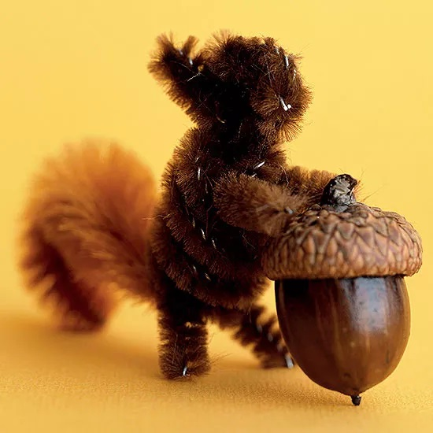

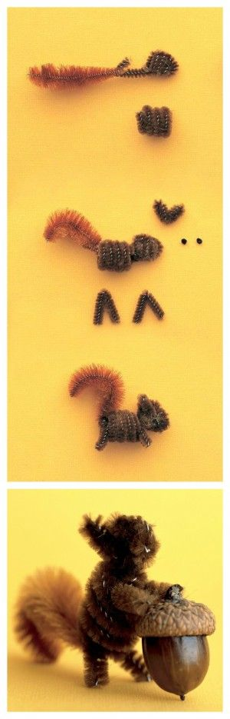
To Make a Squirrel
- Make basic head shape, leaving a shorter length on the end of the head piece for a hook. Hook a piece of fluffy pipe cleaner onto it. Make a short body.

- Slide body into place. Shape ears. Slip through top of head. Cut felt eyes; glue on. Place legs over front and back coils, and twist to secure.

- Curl tail

- Glue an acorn if you can find one to the arms…

