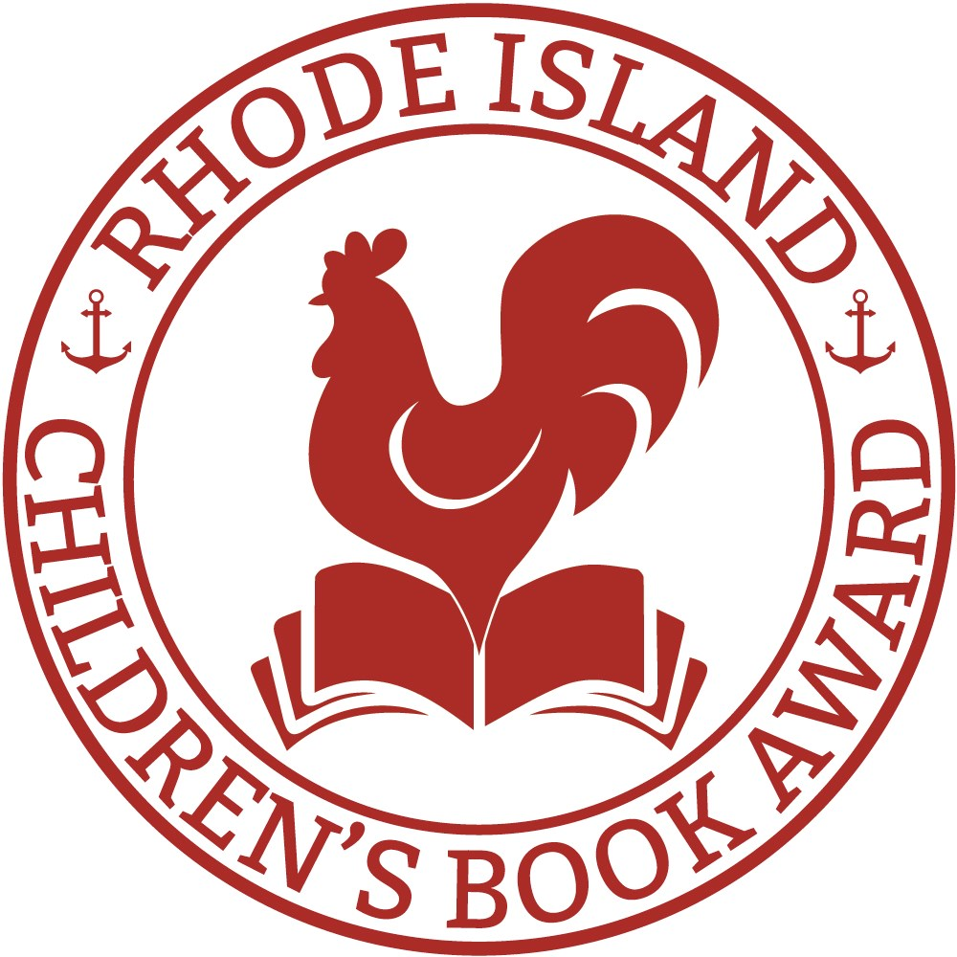
2017 RHODE ISLAND
CHILDREN’S BOOK
AWARD NOMINATIONS

Trombone Shorty, Troy Andrews and Bryan Collier. Grades 3+
Trombone Shorty is a musician who got his start at age four when he first picked up a trombone that was twice his size. By age six, he was playing in the streets of New Orleans. Now he performs with some of the biggest musicians and returns home to share his music with the children of New Orleans. Autobiographical Picture Book.

Ruby on the Outside, Nora Raleigh Baskin. Grades 4+ 11-year-old
Ruby is about to start middle school, and only her aunt knows her deepest secret: her mother is in prison. Then Margalit Tipps moves into Ruby’s condo complex, and the two immediately hit it off. Ruby thinks she’s found her first true-blue friend—but can she tell Margalit the truth about her mom? Realistic Fiction.

A Whole New Ballgame: A Rip and Red Book, Grades 4+
Phil Bildner and Tim Probert. Rip and his best friend Red can’t wait to be on their school’s basketball team. But budget cuts, a focus on test prep, and a new teacher / new basketball coach with tattoos and ear piercings are shaking things up. Realistic Fiction.

Ellie’s Story, W. Bruce Cameron. Grades 4+
From the time she was a puppy, Ellie has been trained as a searchand-rescue dog. She soon learns, though, that her job isn’t just to save missing or hurt people. Realistic Fiction.

Stella by Starlight, Sharon M. Draper. Grades 4+
When a burning cross set by the Ku Klux Klan causes panic and fear in 1932 North Carolina, Stella must face prejudice and find the strength to demand change in her segregated town. Historical Fiction.

The Honest Truth, Dan Gemeinhart. Grades 5+
A 12-year-old boy named Mark, tired of being sick with cancer, runs away from home with his dog, camera, notebook, and a plan. A plan to reach the top of Mount Rainier, even if it's the last thing he ever does. Realistic Fiction.

Took, Mary Downing Hahn. Grades 5+
Daniel and his sister move to a new house and are told stories about a ghost witch who lives nearby. Daniel doesn’t believe in the stories until his sister gets a doll and her behavior changes. One day she disappears and Daniel must face the ghost. Horror.

Full Cicada Moon, Marilyn Hilton. Grades 4+
It's 1969, and the Apollo 11 mission is ready to go to the moon. But for half-black, half-Japanese Mimi, moving to a predominantly white Vermont town is enough to make her feel alien. Mimi's appearance is all anyone notices. She struggles to fit in even as she fights for her right to stand out. Historical Fiction / Verse.

Paper Things, Jennifer Richard Jacobson. Grades. 5+
When forced to choose between staying with her guardian and being with her big brother, Ari chooses her big brother Gage. There’s just one problem—Gage doesn’t have a place to live. Realistic Fiction.

How to Swallow a Pig, Steven Jenkins and Robin Page. Grades 3+
How do animals survive in the wild? Do you want to learn to crack a nut like a crow? Follow the imaginative and humorous step-bystep instructions animals use to find food, protect themselves, and build homes. Nonfiction Picture Book.

Masterminds, Gordon Korman. Grades 4+
Eli and the other kids in Serenity, New Mexico are told they're lucky to be living in the most perfect town in America. But when Eli and his friends discover the connection between Serenity and the greatest criminal masterminds in history, they must make a daring escape. Adventure / Mystery.

The Misadventures of the Family Fletcher, Dana Alison Levy. Grades 3+
Four brothers, two dads, and a grumpy neighbor learn how friendships can change; identities will evolve and that making mistakes is an essential part of life. Realistic Fiction.

Ratscalibur, Josh Lieb. Grades 3+
When Joey moves to the city, his uncle gives him a rat who turns out to be a powerful "ragician", and whose bite turns Joey into a rat, too. Joey begins a quest to reverse the spell. When he pulls Ratscalibur from the scone, he finds himself the unwilling hero of a prophecy. But will he save the rats? Fantasy.

A Handful of Stars, Cynthia Lord. Grades 4+
When Lily's blind dog runs away, it's Salma Santiago who manages to catch him. Salma, the daughter of migrant workers, is in the small Maine town with her family for the blueberry-picking season. Salma and Lily become friends but will face some tough truths about friendship and belonging. Realistic Fiction.

Upside Down Magic, Grades 4+
Sarah Mlynowski, Lauren Myracle, and Emily Jenkins. Instead of being able to turn herself into a dragon or a kitten, Nory turns herself into both creatures at the same time: a dritten. Nory is a student in the first-ever Upside-Down Magic class, where magic has a tendency to turn wonky. Fantasy.

Into the Killing Seas, Michael P. Spradlin. Grades 4+
World War II is raging on as 12-year old Patrick and his brother Teddy hide on the USS Indianapolis in order to reunite with their parents in the Philippines. When Japanese torpedoes hit the ship, the brothers are stranded on a piece of debris without food or water in shark-infested waters. Historical Fiction.

Growing Up Pedro: How the Martinez Brothers Made It from the Dominican Republic All the Way to the Major Leagues,
Matt Tavares. Grades 3+
Pedro Martínez would dream of the day he and his brother Ramon, the best pitcher he had ever seen, would play together in the major leagues. But he could never imagine World Series championships, Cy Young awards, and All-Star teams. Biographical Picture Book.

Sisters, Raina Telgemeier. Grades 4+
Raina can't wait to be a big sister but Raina’s relationship with her little sister Amara is anything but wonderful. Now they have a baby brother and there are new parent issues. Can they figure out how to get along? They are sisters, after all. Graphic Novel.

Hilo: The Boy Who Crashed to Earth, Judd Winick. Grades 3+
D.J. isn’t very good at anything, except being friends with Gina.
When a mysterious boy named Hilo falls out of the sky, D.J. and Gina must figure out where he came from and why he is here before it is too late. Graphic Novel / Science Fiction.

Lillian's Right to Vote: A Celebration of the Voting Rights
Act of 1964, Jonah Winter. Grades 3+
Lillian, a 100-year old African American woman, walks up the steep hill to her polling place to vote. As she moves, she sees her ancestors and the hardships they endured to have voting rights in America. Nonfiction Picture Book.

