Make your own snow globe!

1
Ask your child if he can find the perfect plastic figurine or Lego piece to use in his snow globe. No sense in buying a new one, if there’s already something at home! (We’ve provided two trees or a tree and a deer.)
2
Put hot glue on the inside of the jar’s lid. Place and stick your child’s plastic figurine on it as well as snow to the inside circle of the lid (not on the rubber ring.
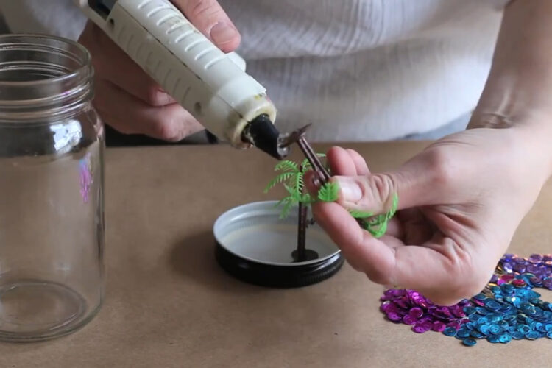

3
Fill the jar with cold water (can be distilled for more clarity.)
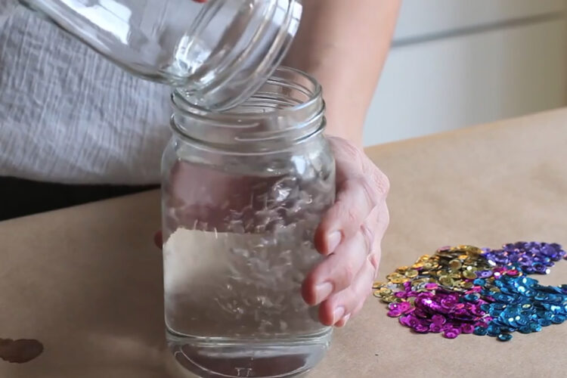
4 Add 1-2 teaspoons of glitter and stir.
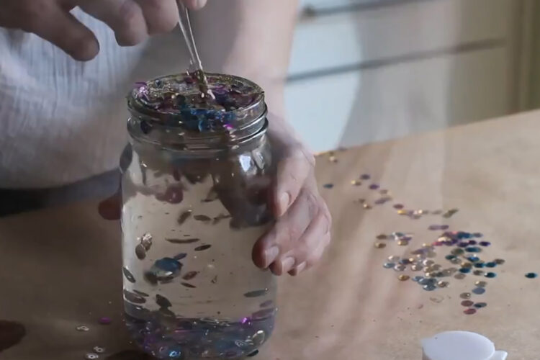

5
Add a few drops of glycerin.
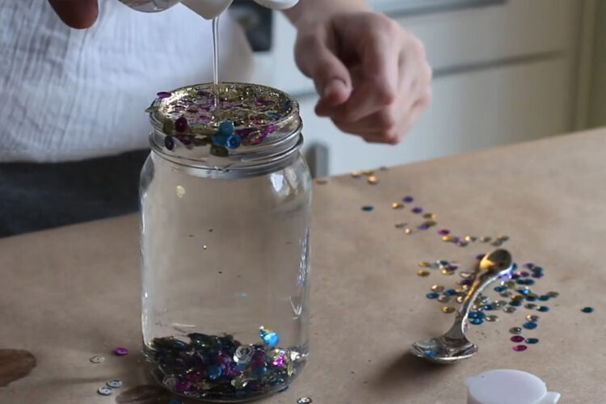
6
Screw the lid on the jar. You can glue it if you're concerned about your child trying to open it.
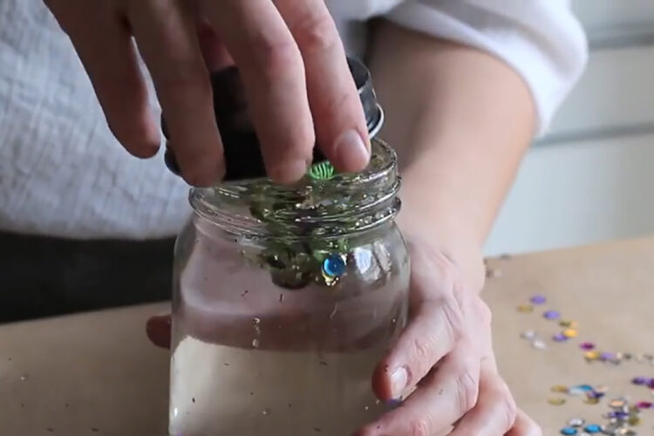

7
That's it! Have your child shake the jar or tip it upside down to make it "snow."
